DBMS Assignment 2
Name: Shubham Rawat
Course: MCA

Ans A

create table Department (department_Number number, Department_Name Varchar2(10), Location_ Varchar2(15));
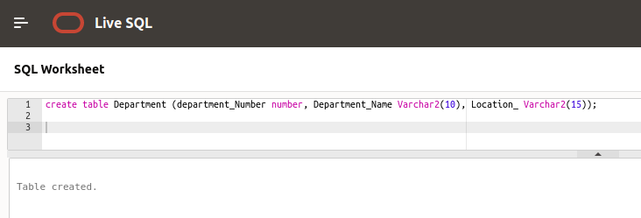

Ans B.a

alter table Department rename to Dept;
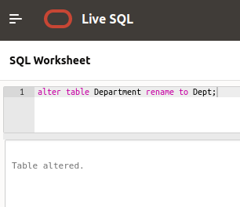

AnsB.b

alter table Dept rename column department_Number to deptno;
alter table Dept rename column Department_Name to DName;
alter table Dept modify(deptno number(5) primary key, DName varchar2(15) not null, Location_ Varchar2(15) default 'Delhi');
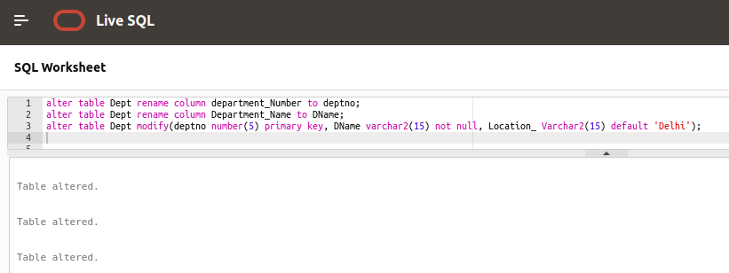

Ans C

create table Employees(Employee_number number(10),
Employee_name varchar2(10),
job varchar2(10),
mrg number(4),
hiredate date,
salary number(7,2),
commission number(7,2),
departmentID number);
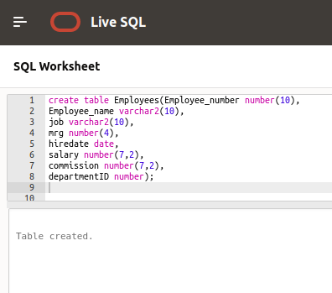

Ans D.a

alter table Employees rename to Emp;
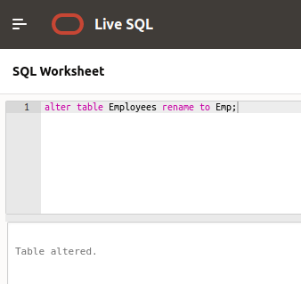

Ans D.b

alter table Emp rename column Employee_number to empno;
alter table Emp rename column Employee_name to ename;
alter table Emp rename column salary to sal;
alter table Emp rename column commission to comm;
alter table Emp rename column DepartmentID to deptno;

alter table Emp modify(empno number(4) primary key,
ename not null,
job check (job in('President','Manager','Analyst','Clerk','Salesman')),
hiredate default(current_date),
sal check (sal >= 10000 and sal <= 100000),
comm default 0 ,
deptno number(2),
foreign key (deptno) references Dept(deptno)
